Justin Dietrich, Ryan Scott

9/25/2022

CST - 310

Prof. Citro

Project 3: Your Surrounding World

For projects 2-5, we are to take a picture of a scene from our everyday lives and use OpenGL with C++ to recreate it digitally. This part has us planning how we are going to represent each object in the image.

**List the objects in the foreground, background, and in-between.**

Objects in Foreground:

* Sticky Notes
* Scissors
* DS’s
* Cartridge cases and Gameboy
* Headphones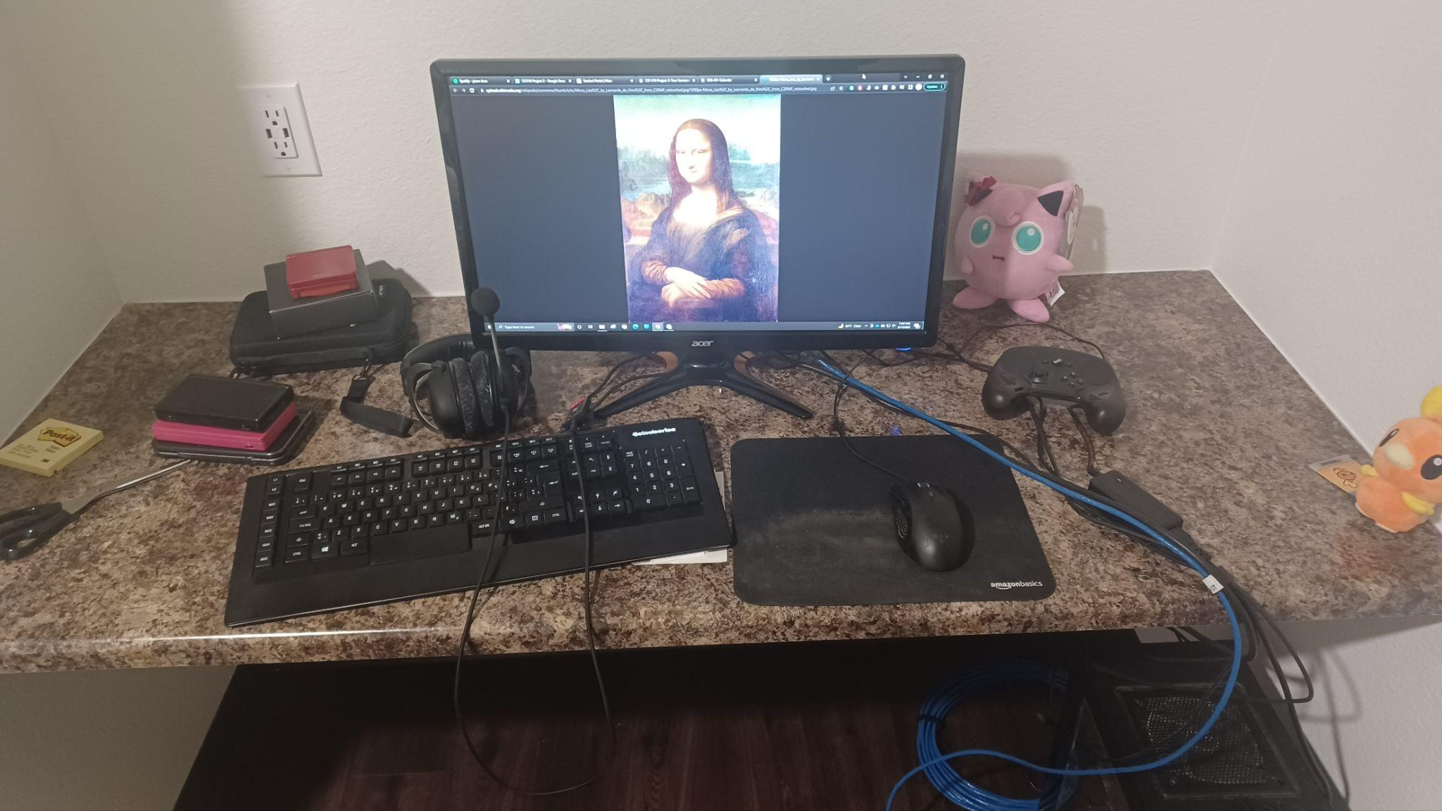
* Keyboard
* Monitor with Painting
* Mouse and Mousepad
* Controller
* Two plushes
* Wall Outlet

In-Between Objects:

* Desktop Tower
* Wire coil
* Wires

Objects in Background:

* Granite Desk
* Walls
* Floor

Main Objects:

* Monitor with Painting
* Plushes
* Keyboard
* Mouse
* DS’s
* Cartridge cases and Gameboy

**Identify the main objects in the scene (e.g., buildings, trees, bridge).**

**Describe key characteristics of the scene (e.g., ambience).**

The scene is warmly lit and contains shadows noticeably behind the monitor, under the desk, to the left of the outlet, and behind the two item stacks. Most items are black. The scene has a cluttered feel, with many different kinds of items scattered around and wires going across. Most of the shapes are non-abstract, and in they are mostly rectangular, round, or lines.

**Explain how you would approach rendering each object in the scene**

**Sticky Notes:** Would just be a yellow rectangular prism.

**Scissors:** Two hollow ovals connected to the base of a long triangle.

**DS’s:** Three rectangular prisms, each with the correct size and color.

**Cartridge Cases and Gameboy:** Three rectangular prisms, much like the DS’s. The strap could be two thin rectangles.

**Headphones:** An almost 2D curve with two 3D ovals on the ends. The microphone would just be a vector with a sphere on the end. Its wire could also be a vector.

**Keyboard:** A rectangle with a bunch of little squares on top. It would be tedious to place every square, so we might make an algorithm for placing the squares and hard-code the ones of different sizes. They would all have a white shape for each key.

**Monitor with Painting:** The stand could be two rectangles connected to a rectangular prism. The screen would be a rectangle. The image, which is the center of the scene, would be drawn to the best of our ability with what we have. It would go like an oval for the head, hard-coded polygons for the hair, face, and hands, and a combination of rectangles and rounded shapes for the arms and rest of the body.

**Mouse and Mousepad:** The mousepad could be a rectangle with rounded edges, and the mouse could be a semi-oval with a short cylindrical scroll wheel.

**Controller:** Two 3D ovals connected by a rectangular prism. There would be a bunch of colorful little circles for the buttons and 3D shapes for the joystick.

**Two Plushes:** Sphere could make up the main bodies, with cones and other polygons sticking out. The features could be represented with circles.

**Wall Outlet:** A couple of small rectangles can represent the outlet accurately

**Granite Desk:** A rectangle could make the whole thing. A texture could be made using random vectors or importing a texture.

**Walls:** Planes are all that’s needed.

**Wires:** Connecting line strips

**Desktop Tower:** Rectangular prism with some circles and squares for features.

**Floor:** Just a plane.

**Wire Coil:** A line loop, or hallow circle.

We will have to utilize a variety of techniques to render each object in the scene. Simple quads can be employed to create the less detailed parts of the scene, such as **1) Floors** and **2) Walls**. A set of elongated cubes can be used to represent simple edged objects, such as the **3) Sticky Notes**, **4) Desktop Tower**, **5) DS’s**, and **6) Cartridge Cases**. A line strip can be used to represent the **14) Wires** with the potential to use a line loop to represent the **7) Wire Coil**. Many rectangles can be used to effectively represent the **8) Wall Outlet** with more efficiency. The **17) Monitor** can be represented with a 3D object while the **18) Mona Lisa image** can be rendered to a texture and displayed on the screen.

**Rank all the objects in the scene in order of rendering difficulty. NOTE: You will have to render at least 10 different objects in the next project.**

Difficulty (1 = easiest):

1. Floor
2. Walls
3. Sticky Notes
4. Desktop Tower
5. DS’s
6. Cartridge Cases and Gameboy
7. Wire Coil
8. Wall Outlet
9. Scissors
10. Mouse and Mousepad
11. Granite Desk
12. Controller
13. Headphones
14. Wires
15. Keyboard
16. Plushes
17. Monitor
18. Painting on Monitor

**Draw a geometrical representation of the picture on paper, by hand, using pencil only.**

Geometrical Representation:

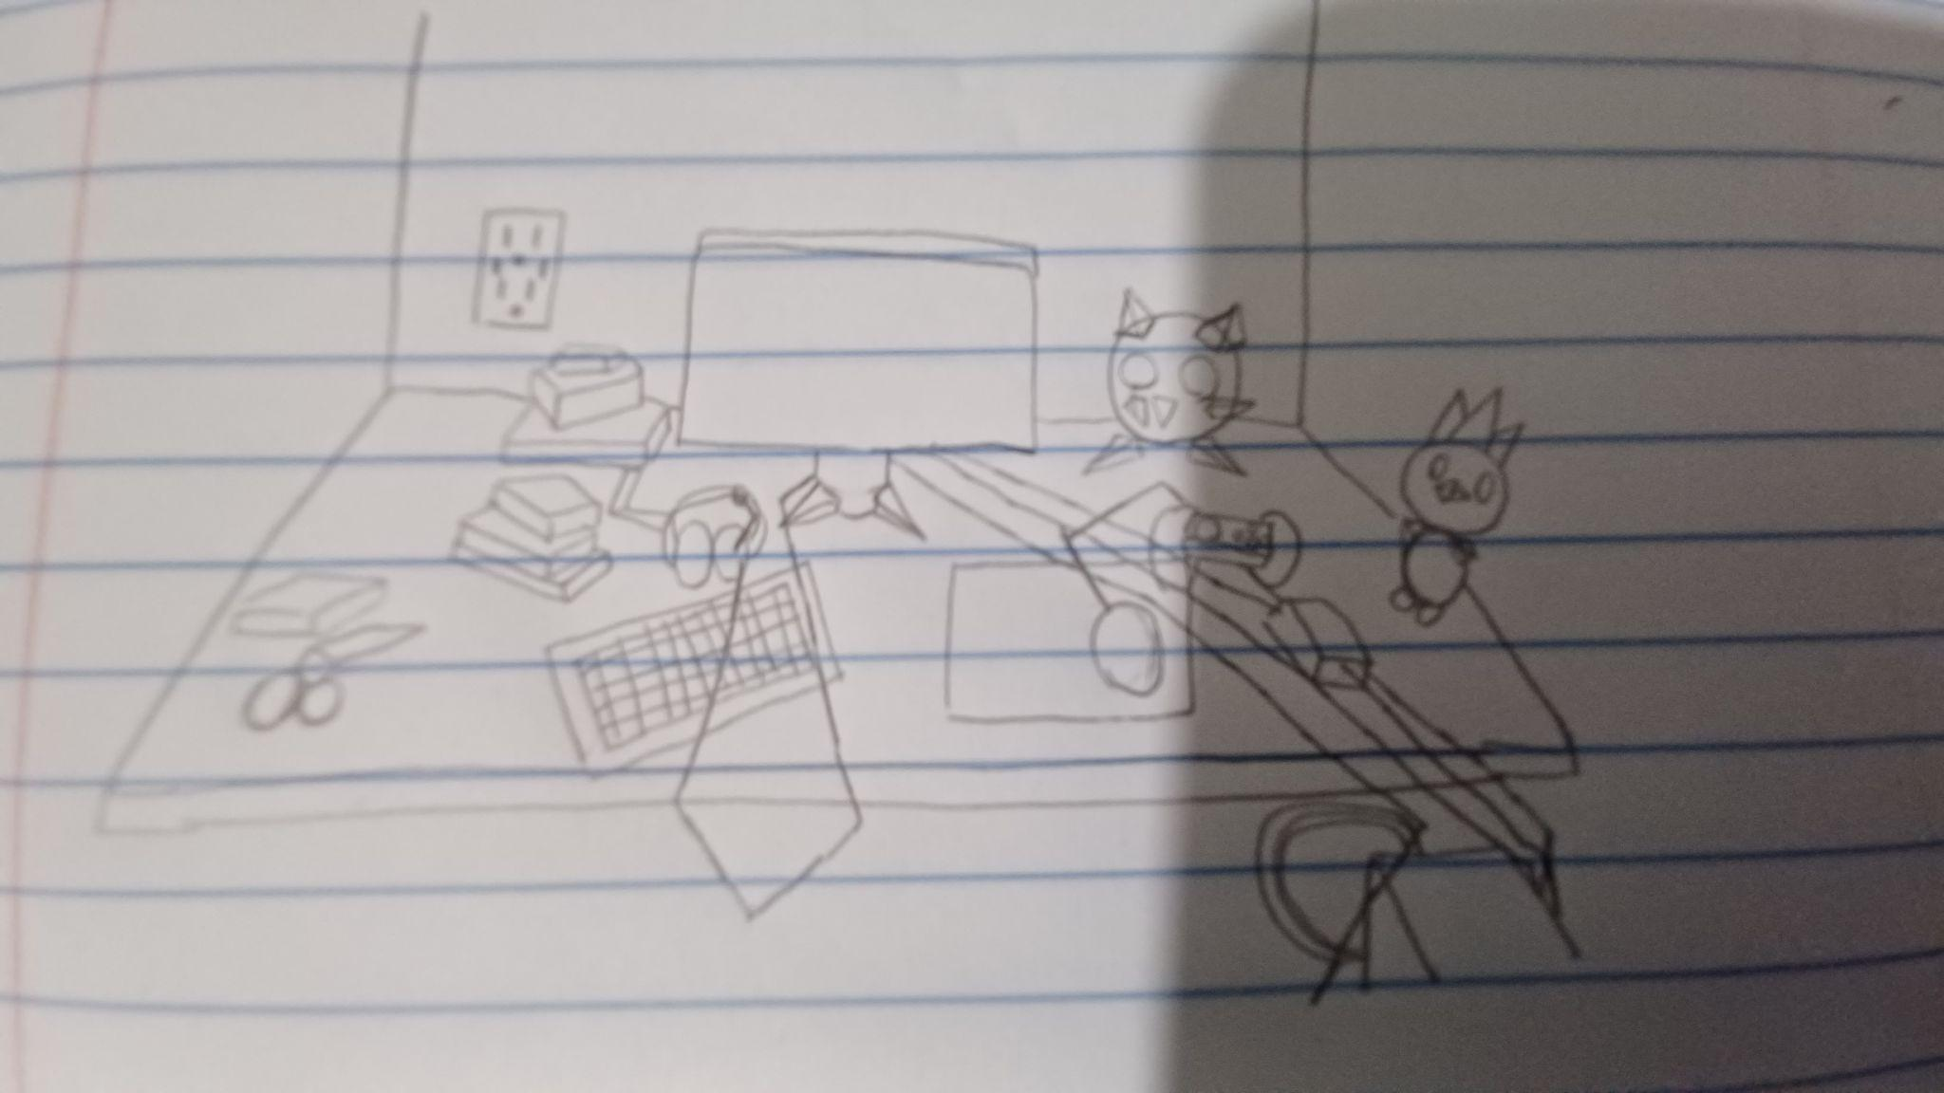

The geometrical representation is textureless, and is mostly just to show the shapes of the objects when recreated in OpenGL. Some shapes are more jagged than the original, but it’s up to how much time is spent creating more vertices in OpenGL that could smooth things out. The perspective is a bit off in the hand-drawn image, but that’s just because perfect perspective is hard to replicate and I’m not an awesome artist.